**Init Containers**

* Overview: Init Containers enable separation of concerns by providing a separate lifecycle for initialization related tasks distinct from main application containers.
* Init Containers in k8s are part of Pod definition, and they separate all containers in the Pods into two groups
  + Init Containers
  + Application Containers
* All init container are executed in sequence & all of them have to terminate successfully before the application containers are started up.

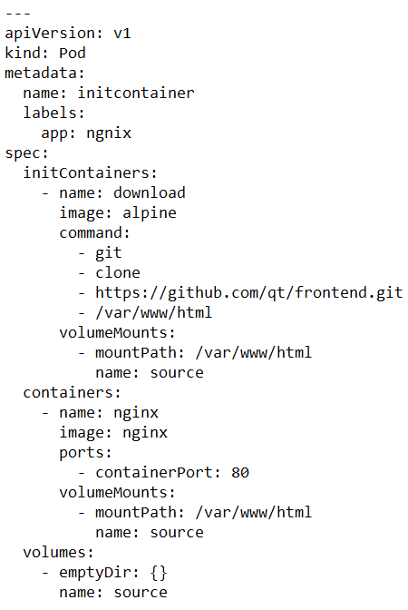

**Sidecar**

* A Sidecar container extends and enhances the functionality of a pre-existing container without changing it. 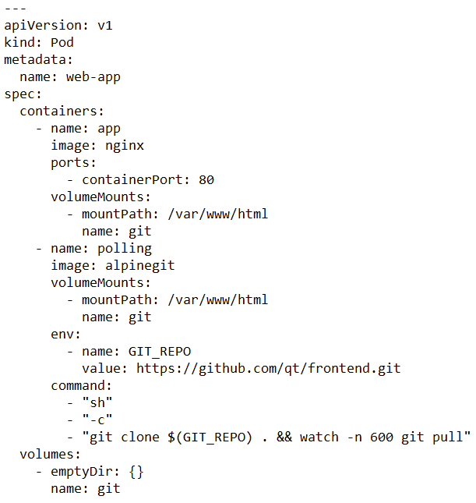

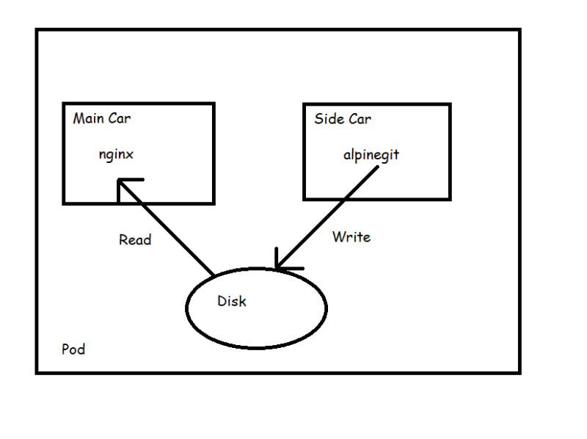

Now we can use side car

* to export logs
* synchronize directories

**Adapter:** Converting from one form to another form.

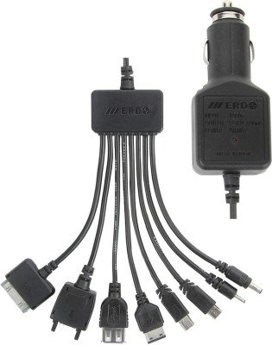

* Adapter pattern takes a heterogenous containerized system and makes it confirm to consistent unified interface with standard and normalized format to be consumed by outside world.
* Adapter pattern inherits all the characteristics from Sidecar, but has the single purpose of providing adapted access to the application
* We have an application which is composed of multiple microservices written in different languages
* So, we need to monitor the application i.e. we want applications to expose the metrics in the same format to the monitoring tool. 